Transcript of the 1786 Sale Catalogue for the sale of Freehold Estates in Turvey, Newton and Clifton,

The original and very frail document may be found in the Bedfordshire Archives.

THE
P A R T I C U L A R S
OF
A CAPITAL AND VERY VALUABLE
FREEHOLD ESTATE
DESIRABLY SITUATEIN THE PARISHES OF
TURVEY, NEWTON AND CLIFTON
(Seven Miles from the Town of Bedford, Four from Olney and Eight from Newport Pagnel)
In the Counties of BEDFORD and BUCKS:
Comprising

THE DEfIRABLE MANOR OF TURVEY
Co-extenfive with the Parifh, and bounded by the River Ouse for near Two Miles, in which there is the fole right of fishery,
And
The PERPETUAL ADVOWSAN and next PRESENTATION
to the RECTORY of TURVEY

also

The Manor of Clifton
AND
Nineteen eligible compact Farms
containing

THREE THOUSAND FIVE HUNDRED AND FORTY THREE ACRES of fertile Meadow, Pasture and Arable Land

All inclofed and well Fenced (except One Hundred and Sixty-five acres)
With suitable FARM HOUSES and OUT-BUILDINGS,

A WATER CORN MILL, three PUBLIC HOUSES, and sundry messuages,

THE WHOLE LET TO UNEXCEPTIONABLE GOOD TENANTS
MESSRS, DAVISON, SKEVINGTON, BATTAMS, JONES, ROWE, PEARSON, SHEFFIELD, LAWRENCE, FOWLER, ALLEBONE, MANNING AND OTHERS

The annual rental
THE THOUSAND AND FORTY SIX POUNDS FOURTEEN SHILLINGS
Which will be sold at auction
By Mr. Skinner and Co.
On Wednesday the 22nd of November 1786,
At Twelve o’clock
At Garraway’s Coffee-house, Change-Alley, London
IN SIX LOTS______________________________________________-

To be viewed by applying to THOMAS TANDY, at TURVEY, of whom printed particulars may be had:

Also of Mr John Higgins, at Weston Underwood, near Olney; at the Post-house at Newport and Dunstable; Swan Bedford; Sun Hitchen; at the place of sale; and of Mr Skinner and Co., Aldersgate Street, London.

Lot I consisted of the advowson and presentation to the Rectory of Turvey
Lodge Farm (Mr. John Davison)
Hall Farm (Mr. Samuel Skevington)

Lot II consisted of Eyle’s late Farm. (Mr. Thomas Battame)
Garden Field Farm (Mr. Thomas Battame)
Fowler’s late Farm (Mr. Thomas Battame)
Horse Close Farm (Mr. Thomas Battame)
West Fields Farm (Mr. Thomas Davison)
The Tinker Public House
38 cottage Houses

Lot III consisted of the Manor of Turvey
Grove Farm (Revd. Mr. Thomas Jones)
Williamson’s or Redland’s Farm (Revd. Mr. Thomas Jones)
Mount Pleasant Farm (Messrs. William and Austin Sheffield)

The ABBEY FARM, in the occupation of Mrs Sarah Lawrence, on lease for 7 years from Michaelmas 1785 at per annum £116 4s 0d

 | A (acres) | R (roods) | P (perch)
Home and Homestead | 4 | 0 | 0
Sharp’s Close | 7 | 0 | 0
Edmunds | 16 | 0 | 15
Brook Close | 3 |  | 24
New Close | 9 | 3 | 23
Mortar Pits | 33 | 2 | 23
Long Edmunds | 40 | 2 | 35
Grindstone Hill | 39 | 2 | 36
Capron’s Close | 18 | 0 | 0
Miller’s | 5 | 2 | 16
Total Acres in Abbey Farm: 177 3. 22

Quality of Land

 | A (acres) | R (roods) | P (perch)
Meadow and Pasture | 45 | 0 | 0
Arable | 132 | 3 | 22

The Water Corn Mill, with Barker’s Close and Old Parsonage Close (Mr. Skevington Davison)
The Three Fishes’ Public House with Puddles Close (Mr. Martin Coles)
The Chequers Public House (Mr. James Stanton)
62 Cottage Houses

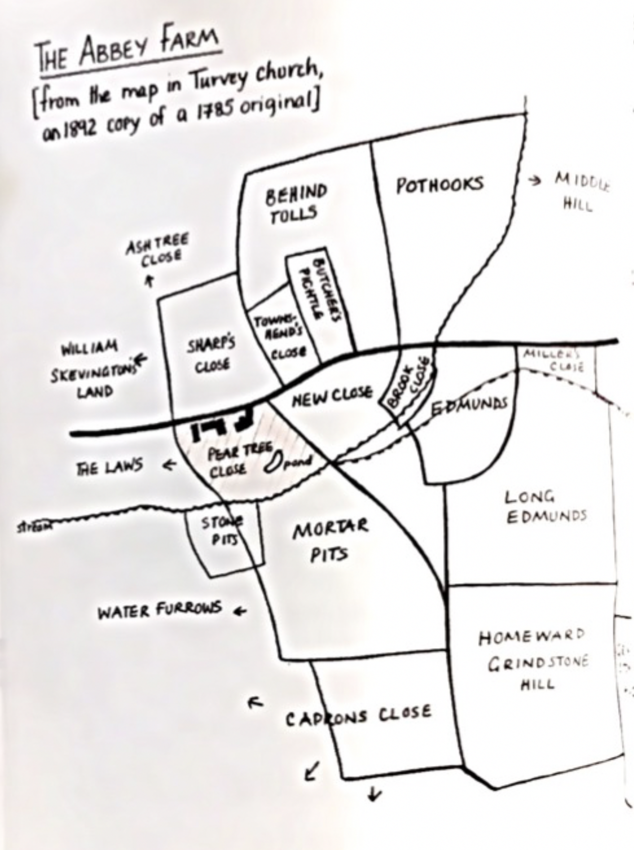

Lot IV consisted of Part of ABBEY FARM in the occupation of Mr. Lavendon Fowler, Tenant at Will, at per annum £50

 | A (acres) | R (roods) | P (perch)
Butcher’s and Tolls | 3 | 3 | 0
Chalsoe | 21 | 1 | 5
Pothooks | 26 | 3 | 26
Townsend’s Close | 6 | 0 | 0
Part of Turvey Farm | 24 | 0 | 26
Total Acres in part of Abbey Farm 83 0 17

Quality of Land

 | A (acres) | R (roods) | P (perch)
Meadow and Pasture | 10 | 0 | 0
Arable | 73 | 0 | 17

Turvey Farm (Mr. Hugh Row)
Bayden Farm (Mr. William Skevington)
7 Cottage Houses

Lot V consisted of Pixhill Farm (Mr. Daniel Allebone)
Elderswell Farm (Mr. William Pearson)
2 Cottage Houses

Lot VI consisted of the Manor of Clifton (Reynes)
Newton Park Freehold Farm (Mr. John Manning)
Clifton Freehold Farm (Mr. Thomas Davison)
Some freehold Cottage Houses and gardens in Clifton
Clifton Leasehold Farm (Mr. Thomas Davison)

___________________________________________________________________________

The Sale

A mistake was made at the sale in that the Advowson was not included in Lot 1 and was accidently included in a lot sold to Charles Higgins. In 1788 Charles Higgins sold, with the Permission of the Earl of Peterborough, the Advowson to William Fuller for £1 500 (=£ in 2018)

Lot I, The Advowson, Lodge and Hall Farm, was purchased by William Fuller (1705 – 1800) a banker of Lombard Street, London and described as “the richest man in England” for £9,200 (£2m in 2018) (Ref Bedfordshire Archives HI36)

Lot II, 5 farms, The Tinker Public House and 38 cottages, was purchased by John Higgins of Weston Underwood (1740-1813) for £10,142 (£2.17m in 2018 (Ref Bedfordshire Archives HI26)

Lot III, The Manor of Turvey, the Grove, Williamson’s and Mount Pleasant Farms and part of the Abbey Farm in the occupation of Mrs Sarah Lawrence was purchased by Charles Higgins (1725 - 1792) for £11000 (£2.4m in 2018) (Ref Bedfordshire Archives HG1/1

Lot IV, Turvey and Bayden Farms plus the part of the Abbey Farm occupied by Mr Lavendon Fowler together with 7 cottages was purchased by Thomas Garrett (1722 – 1792) of London, co-owner of the Grocery business involving Charles Higgins for £ 6000 (£ 1.3m in 2018) (Ref Bedfordshire Archives Z178/15).

Lot V, Pixhill and Elderswell Farm with two cottages was purchased by Charles Higgins (1725 -1792) for £ 4700 (£1.2m in 2018) (Ref Bedfordshire Archives HI30)

Lot VI, The Manor of Clifton, three farms and some cottages was purchased by William Fuller (1705 – 1800) for £1700 (£370000 in 2018) (Ref Bedfordshire Archives H144)

